Problem Statement - Display Employee List and Edit Employee form using RESTful Web Service
Codes:
Employee.xml:
<?xml version="1.0" encoding="UTF-8"?>
<beans xmlns="http://www.springframework.org/schema/beans"
xmlns:xsi="http://www.w3.org/2001/XMLSchema-instance"
xsi:schemaLocation="http://www.springframework.org/schema/beans
https://www.springframework.org/schema/beans/spring-beans.xsd">
<bean id="dept1" class="com.cognizant.springrestemployee.model.Department">
<property name="id" value="1"/>
<property name="name" value="IT"/>
</bean>
<bean id="skill1" class="com.cognizant.springrestemployee.model.Skill">
<property name="id" value="1"/>
<property name="name" value="Java"/>
</bean>
<bean id="employee1" class="com.cognizant.springrestemployee.model.Employee">
<property name="id" value="1001"/>
<property name="name" value="John Doe"/>
<property name="dob" value="1990-01-01"/>
<property name="department" ref="dept1"/>
<property name="skillList">
<list>
<ref bean="skill1"/>
</list>
</property>
</bean>
<bean id="employeeList" class="java.util.ArrayList">
<constructor-arg>
<list>
<ref bean="employee1"/>
</list>
</constructor-arg>
</bean>
</beans>
EmployeeService.java:
package com.cognizant.springrestemployee.service;
import com.cognizant.springrestemployee.dao.EmployeeDao;
import com.cognizant.springrestemployee.model.Employee;
import org.springframework.beans.factory.annotation.Autowired;
import org.springframework.stereotype.Service;
import org.springframework.transaction.annotation.Transactional;
import java.util.List;
@Service // Marks this class as a Spring service
public class EmployeeService {
@Autowired
private EmployeeDao employeeDao;
@Transactional // Optional for this read method, useful in case of future DB interactions
public List<Employee> getAllEmployees() {
return employeeDao.getAllEmployees();
}
}
EmployeeController.java:
package com.cognizant.springrestemployee.controller;
import com.cognizant.springrestemployee.model.Employee;
import com.cognizant.springrestemployee.service.EmployeeService;
import org.springframework.beans.factory.annotation.Autowired;
import org.springframework.web.bind.annotation.*;
import java.util.List;
@RestController
public class EmployeeController {
@Autowired
private EmployeeService employeeService;
@GetMapping("/employees")
public List<Employee> getAllEmployees() {
return employeeService.getAllEmployees();
}
}
EmployeeDao.java:
package com.cognizant.springrestemployee.dao;
import com.cognizant.springrestemployee.model.Employee;
import org.springframework.context.support.ClassPathXmlApplicationContext;
import org.springframework.stereotype.Repository;
import java.util.List;
public class EmployeeDao {
public static List<Employee> EMPLOYEE_LIST;
// Static block loads employee.xml only once when the class is first loaded
static {
// Load Spring context from XML
ClassPathXmlApplicationContext context = new ClassPathXmlApplicationContext("employee.xml");
// Get the bean named "employeeList" (defined in employee.xml)
EMPLOYEE_LIST = (List<Employee>) context.getBean("employeeList");
// Close context to release memory
context.close();
}
// Method to return the employee list
public List<Employee> getAllEmployees() {
return EMPLOYEE_LIST;
}
}
SpringrestemployeeApplication.java:
package com.cognizant.springrestemployee;
import org.springframework.boot.SpringApplication;
import org.springframework.boot.autoconfigure.SpringBootApplication;
@SpringBootApplication
public class SpringrestemployeeApplication {
public static void main(String[] args) {
SpringApplication.run(SpringrestemployeeApplication.class, args);
}
}
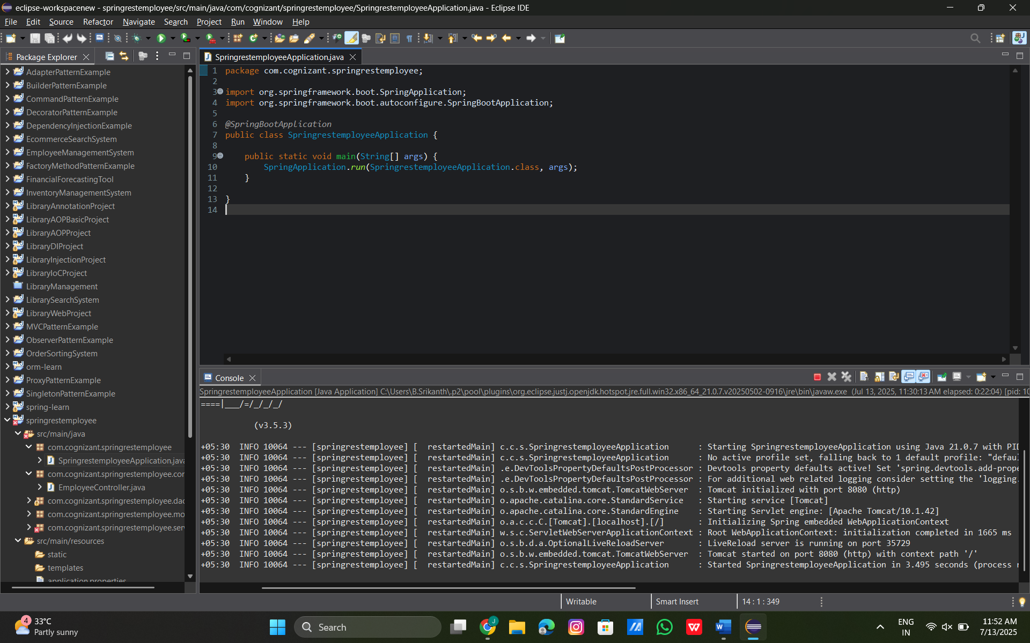
Hands On – 2
Create static employee list data using spring xml configuration
Codes:
Employee.xml:
<?xml version="1.0" encoding="UTF-8"?>
<beans xmlns="http://www.springframework.org/schema/beans"
xmlns:xsi="http://www.w3.org/2001/XMLSchema-instance"
xsi:schemaLocation="http://www.springframework.org/schema/beans
<bean id="employeeList" class="java.util.ArrayList">
<constructor-arg>
<list>
<bean class="com.example.model.Employee">
<property name="id" value="1"/>
<property name="name" value="John Doe"/>
<property name="department" value="HR"/>
<property name="skills">
<list>
<value>Java</value>
<value>Spring</value>
</list>
</property>
</bean>
<bean class="com.example.model.Employee">
<property name="id" value="2"/>
<property name="name" value="Jane Smith"/>
<property name="department" value="Engineering"/>
<property name="skills">
<list>
<value>SQL</value>
<value>React</value>
</list>
</property>
</bean>
</list>
</constructor-arg>
</bean>
<bean id="departmentList" class="java.util.ArrayList">
<constructor-arg>
<list>
<bean class="com.example.model.Department">
<property name="id" value="D01"/>
<property name="name" value="HR"/>
</bean>
<bean class="com.example.model.Department">
<property name="id" value="D02"/>
<property name="name" value="Engineering"/>
</bean>
</list>
</constructor-arg>
</bean>
</beans>
DepartmentDAO.java:
package com.example.dao;
import com.example.model.Department;
import org.springframework.stereotype.Repository;
import jakarta.annotation.Resource; // Or use javax.annotation.Resource if Jakarta not available
import java.util.List;
@Repository
public class DepartmentDao {
@Resource(name = "departmentList") // This connects it to the bean in employee.xml
private List<Department> departmentList;
public List<Department> getAllDepartments() {
return departmentList;
}
}

SpringRestHandsonApplication.java:
package com.example;
import org.springframework.boot.SpringApplication;
import org.springframework.boot.autoconfigure.SpringBootApplication;
import org.springframework.context.annotation.ImportResource;
@ImportResource("classpath:employee.xml")
public class SpringRestHandsOnApplication {
public static void main(String[] args) {
SpringApplication.run(SpringRestHandsOnApplication.class, args);
}
}
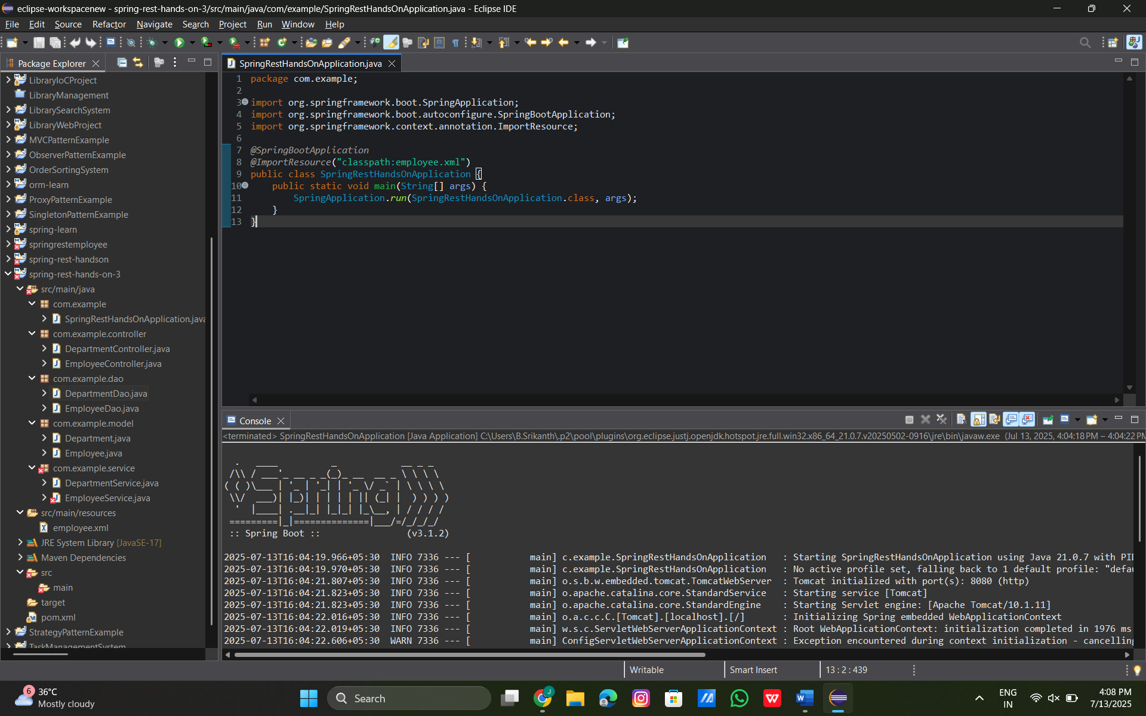

Hands On - 3
Create REST service to gets all employees
Employee.xml:
<?xml version="1.0" encoding="UTF-8"?>
<beans xmlns="http://www.springframework.org/schema/beans"
xmlns:xsi="http://www.w3.org/2001/XMLSchema-instance"
xsi:schemaLocation="http://www.springframework.org/schema/beans
<!-- Employee List Bean -->
<bean id="employeeList" class="java.util.ArrayList">
<constructor-arg>
<list>
<bean class="com.example.model.Employee">
<property name="id" value="1"/>
<property name="name" value="John Doe"/>
<property name="department" value="HR"/>
<property name="skills">
<list>
<value>Java</value>
<value>Spring</value>
</list>
</property>
</bean>
<bean class="com.example.model.Employee">
<property name="id" value="2"/>
<property name="name" value="Jane Smith"/>
<property name="department" value="Engineering"/>
<property name="skills">
<list>
<value>SQL</value>
<value>React</value>
</list>
</property>
</bean>
<!-- Add more employees as needed -->
<bean class="com.example.model.Employee">
<property name="id" value="3"/>
<property name="name" value="Alice Brown"/>
<property name="department" value="Finance"/>
<property name="skills">
<list>
<value>Excel</value>
<value>Analytics</value>
</list>
</property>
</bean>
</list>
</constructor-arg>
</bean>
<!-- Department List Bean -->
<bean id="departmentList" class="java.util.ArrayList">
<constructor-arg>
<list>
<bean class="com.example.model.Department">
<property name="id" value="D01"/>
<property name="name" value="HR"/>
</bean>
<bean class="com.example.model.Department">
<property name="id" value="D02"/>
<property name="name" value="Engineering"/>
</bean>
<bean class="com.example.model.Department">
<property name="id" value="D03"/>
<property name="name" value="Finance"/>
</bean>
</list>
</constructor-arg>
</bean>
</beans>
EmployeeDAO.java:
package com.example.dao;
import com.example.model.Employee;
import jakarta.annotation.Resource;
import org.springframework.stereotype.Repository;
import java.util.List;
@Repository
public class EmployeeDao {
@Resource(name = "employeeList")
private List<Employee> employeeList;
public List<Employee> getAllEmployees() {
return employeeList;
}
}
EmployeeService.java:
package com.example.service;
import com.example.dao.EmployeeDao;
import com.example.model.Employee;
import org.springframework.beans.factory.annotation.Autowired;
import org.springframework.stereotype.Service;
import org.springframework.transaction.annotation.Transactional;
import java.util.List;
@Service
public class EmployeeService {
@Autowired
private EmployeeDao employeeDao;
@Transactional(readOnly = true)
public List<Employee> getAllEmployees() {
return employeeDao.getAllEmployees();
}
}
EmployeeController.java:
package com.example.controller;
import com.example.model.Employee;
import com.example.service.EmployeeService;
import org.springframework.beans.factory.annotation.Autowired;
import org.springframework.web.bind.annotation.*;
import java.util.List;
@RestController
public class EmployeeController {
@Autowired
private EmployeeService employeeService;
@GetMapping("/employees")
public List<Employee> getAllEmployees() {
return employeeService.getAllEmployees();
}
}

SpringRestHandsOnApplication.java:
package com.example;
import org.springframework.boot.SpringApplication;
import org.springframework.boot.autoconfigure.SpringBootApplication;
import org.springframework.context.annotation.ImportResource;
@SpringBootApplication
@ImportResource("classpath:employee.xml")
public class SpringRestHandsOnApplication {
public static void main(String[] args) {
SpringApplication.run(SpringRestHandsOnApplication.class, args);
}
}
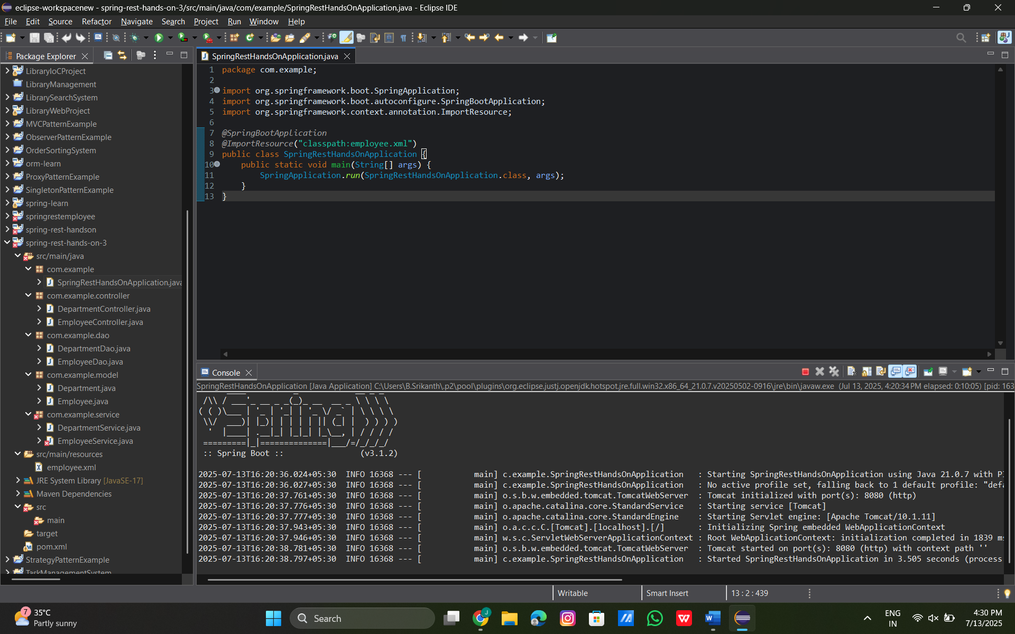

Hands On – 4
Create REST service for department
Codes:
Pom.xml:
<project xmlns="http://maven.apache.org/POM/4.0.0"
xmlns:xsi="http://www.w3.org/2001/XMLSchema-instance"
xsi:schemaLocation="http://maven.apache.org/POM/4.0.0 http://maven.apache.org/xsd/maven-4.0.0.xsd">
<modelVersion>4.0.0</modelVersion>
<groupId>com.example</groupId>
<artifactId>spring-rest-hands-on</artifactId>
<version>1.0.0</version>
<packaging>jar</packaging>
<parent>
<groupId>org.springframework.boot</groupId>
<artifactId>spring-boot-starter-parent</artifactId>
<version>3.1.2</version>
<relativePath/> <!-- lookup parent from repository -->
</parent>
<properties>
<java.version>17</java.version> <!-- or 21 if using Java 21 -->
</properties>
<dependencies>
<!-- REST Support -->
<dependency>
<groupId>org.springframework.boot</groupId>
<artifactId>spring-boot-starter-web</artifactId>
</dependency>
<!-- XML Bean Configuration -->
<dependency>
<groupId>org.springframework</groupId>
<artifactId>spring-context</artifactId>
</dependency>
<!-- Transaction Management (Fixes @Transactional issue) -->
<dependency>
<groupId>org.springframework</groupId>
<artifactId>spring-tx</artifactId>
</dependency>
<!-- Required for @Resource -->
<dependency>
<groupId>jakarta.annotation</groupId>
<artifactId>jakarta.annotation-api</artifactId>
<version>2.1.1</version>
</dependency>
</dependencies>
<build>
<plugins>
<plugin>
<groupId>org.springframework.boot</groupId>
<artifactId>spring-boot-maven-plugin</artifactId>
</plugin>
</plugins>
</build>
</project>
SpringRestHandsOnApplication.java:
package com.example;
import org.springframework.boot.SpringApplication;
import org.springframework.boot.autoconfigure.SpringBootApplication;
import org.springframework.context.annotation.ImportResource;
@SpringBootApplication
@ImportResource("classpath:employee.xml")
public class SpringRestHandsOnApplication {
public static void main(String[] args) {
SpringApplication.run(SpringRestHandsOnApplication.class, args);
}
}

Eclipse IDE Output:
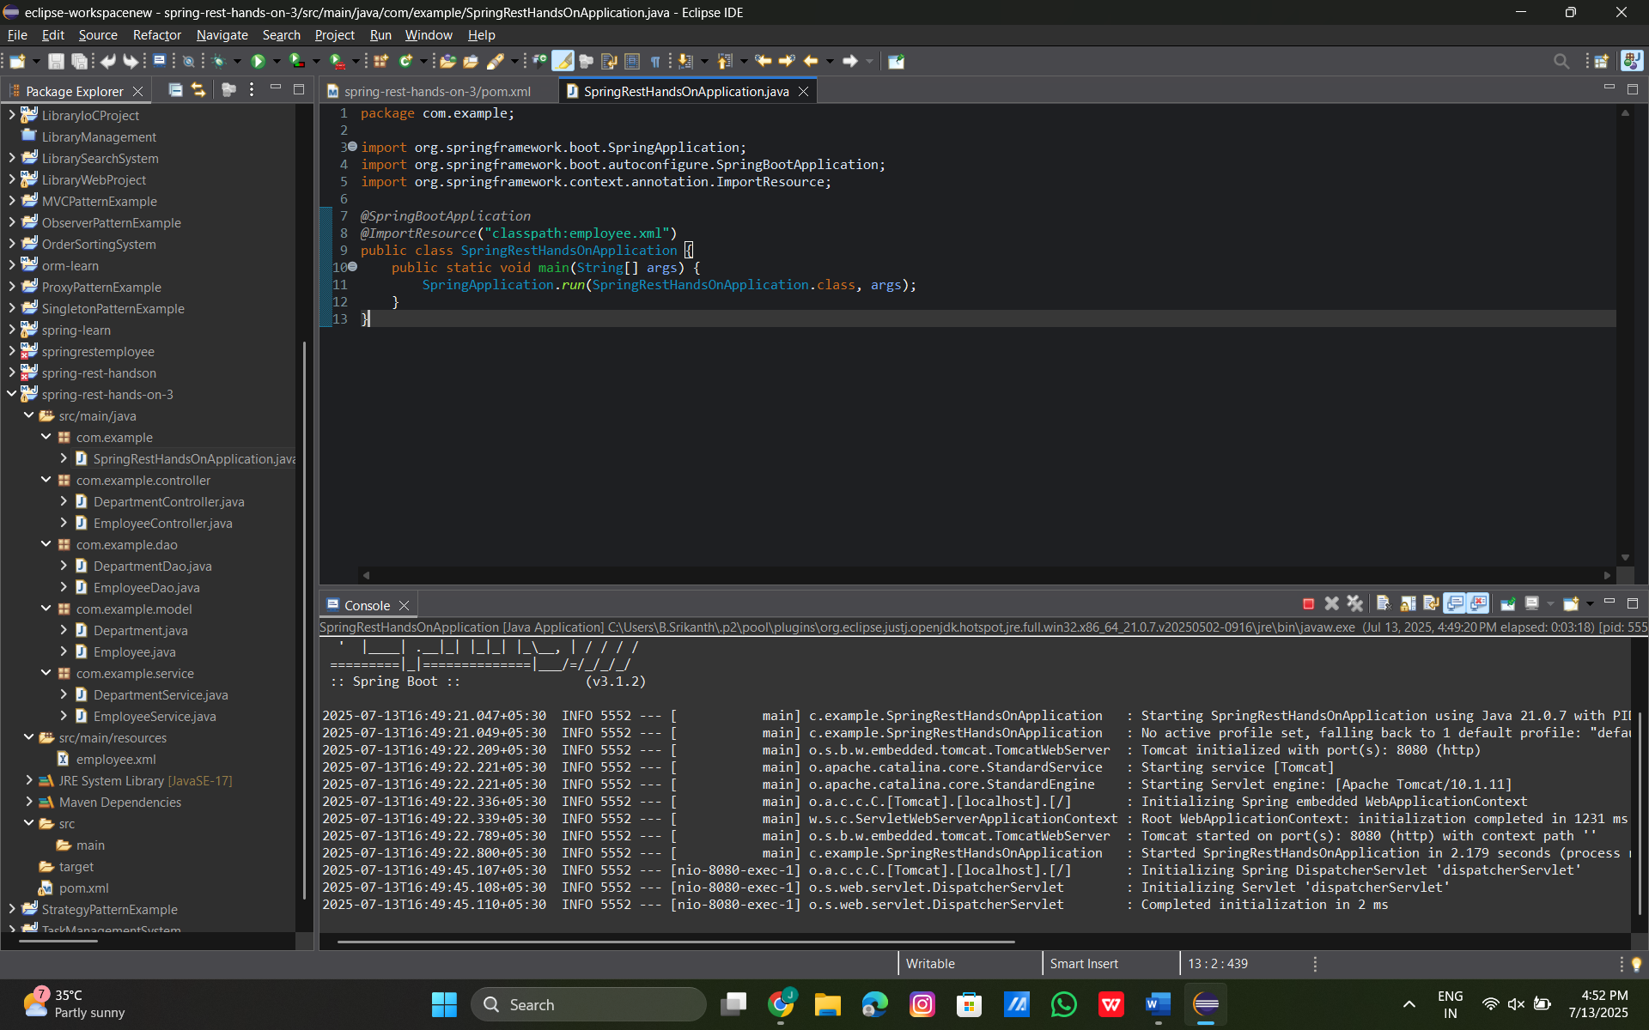

Postman Output:
